Python Naming Convention & PEP8

# Naming Convention

**Modules**: use lowercase letters and underscores

Math_operations.py

**Variables:** Globals variable should be in uppercase with underscores

GLOBAL_VARIABLE = 10

locals variable should follow the same convention as functions

local_variable = 5

**Classes:** CapWords (or CamelCase) convention. This means that the first letter of each word in the class name should be capitalized, and there should be no underscores between words.

class Car

**Exceptions:** names should end with "Error," following the CapWords convention.

except CustomError as ce:

# 

# PEP 8

Ref: [peps.python.org/pep-0008/](http://peps.python.org/pep-0008/)

**Indentation**: Use 4 spaces per indentation level.

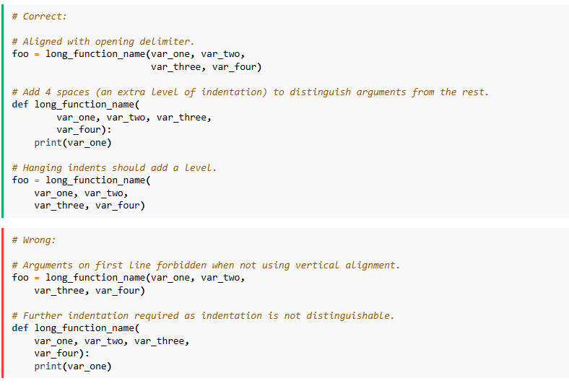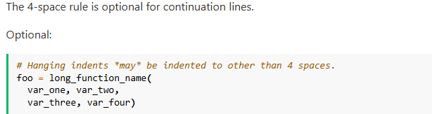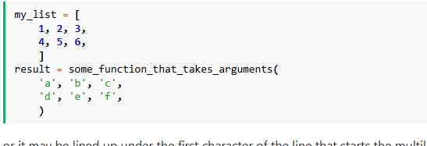s

### [**Tabs or Spaces?**](https://peps.python.org/pep-0008/#tabs-or-spaces)

Spaces are the preferred indentation method.

Tabs should be used solely to remain consistent with code that is already indented with tabs.

**Maximum Line Length:** The Python standard library is conservative and requires limiting lines to 79 characters (and docstrings/comments to 72).

Line break before binary operator.

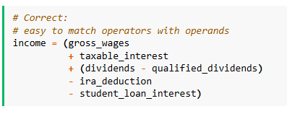.

**Blank lines:**

Surround top-level function and class definitions with two blank lines.

Method definitions inside a class are surrounded by a single blank line.

**Import:**

Imports should be grouped in the following order:

1. Standard library imports.
2. Related third party imports.
3. Local application/library specific imports.

**Whitespace:**

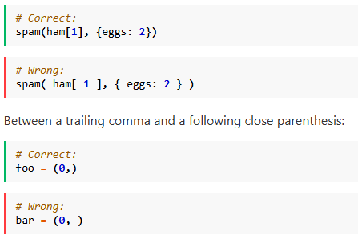**.**

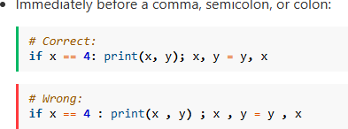**.**

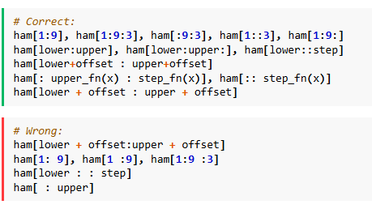**.**

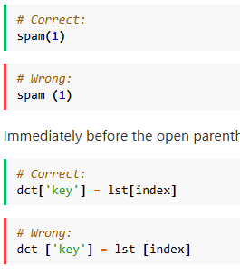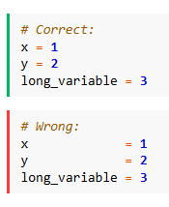

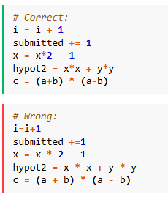

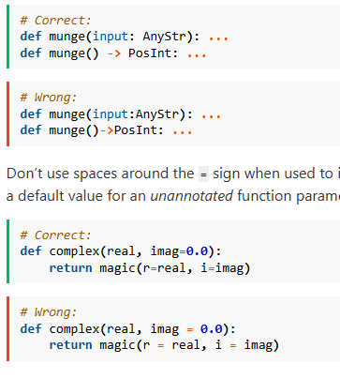

**it does not make sense to have a trailing comma on the same line**

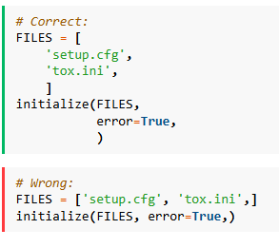**.**

**Inline comments should be separated by at least two spaces from the statement.**

